**Students’ Course Evaluation Questionnaire 2017**

**ANALYSIS REPORT**

The Students’ Course Evaluations of 182 Courses were conducted in 11 Departments in hard-copy proformae. The summary of valid for analysis proformae are tabulated below:

|  |  |  |
| --- | --- | --- |
| **Department** | **Course.Title** | **No. Proformae** |
| **Centre of Pure and Applied Geology** | Advance Stratigraphy | 11 |
|  | Carbonate Sedimentology | 11 |
|  | Coal Exploitation | 14 |
|  | Economic Geology | 42 |
|  | Engineering Geology | 10 |
|  | Exploitation Geology | 17 |
|  | Field Geology and Sedimentery Petrology | 15 |
|  | Geo Physics | 58 |
|  | Geochemistry/Minerology | 8 |
|  | Geological Field and sedimentary Petrology | 9 |
|  | Geological Field Work | 61 |
|  | Micropaleontology | 11 |
|  | Petroleum Geology | 33 |
|  | Remote Sensing and GIS | 54 |
|  | Reservoir Geology | 27 |
|  | Sequence stratigraphy | 36 |
|  | Structural Geology | 6 |
|  | Tectonic Of Pakistan | 5 |
| **Centre of Pure and Applied Geology Total** |  | **427** |
| **Electronics** | Complex Variable And Transform | 68 |
|  | Computer Architecture and Organization | 56 |
|  | Digital Logic Design | 33 |
|  | Digital Signal processing | 45 |
|  | EMF & Theory | 21 |
|  | Engineering Management | 27 |
|  | Microprocessor and Interfacing Technique | 38 |
|  | Microprocessor Architecture and Assembly Language | 31 |
|  | Opto Electronics | 41 |
|  | Signal & System | 33 |
|  | Telecommunication System | 32 |
| **Electronics Total** |  | **425** |
| **Fresh Water Biology & Fisheries** | Aqua Culture | 10 |
|  | Aquatic Bacteria and Fungi | 8 |
|  | English | 8 |
|  | Environmental Science | 15 |
|  | Fish Anatomy | 3 |
|  | Fish Biology | 29 |
|  | Fish Culture | 15 |
|  | Fish Pond Culture | 29 |
|  | Fisheries Niology | 17 |
|  | Fishery Technology | 14 |
|  | Fishries Technology | 7 |
|  | Hydrobiology | 6 |
|  | Icnthyology II | 6 |
|  | Lake management | 5 |
|  | Limnology | 8 |
|  | Mammology | 18 |
|  | Ornithology | 28 |
|  | Physiology | 12 |
|  | Zoology | 10 |
| **Fresh Water Biology & Fisheries Total** |  | **246** |
| **Information Technology** | Computer Vision And Image Processing | 51 |
|  | Information System | 59 |
|  | IP Telephony | 71 |
|  | Network Management & Security | 33 |
|  | Network Management and Security | 19 |
|  | System Administration | 68 |
| **Information Technology Total** |  | **301** |
| **LLB** | Business Law | 85 |
|  | Bussiness Law | 61 |
|  | Civil Liberties & Human Right | 59 |
|  | Civil Procedure Code-II(C.P.C)-II | 78 |
|  | Company Law-II | 77 |
|  | Constitutional History of Pakistan | 56 |
|  | Constitutional Law II | 50 |
|  | Corporate Law-II | 40 |
|  | Criminal Law ii | 32 |
|  | Criminal Procedure Code-II | 119 |
|  | Cyber Law | 42 |
|  | Energy Law | 41 |
|  | English language | 91 |
|  | Environmental Law | 119 |
|  | Fundamentals of Economics | 40 |
|  | Human Rights Law | 83 |
|  | International Humanitarian Law (I.H.L) | 79 |
|  | Interpretation Of Statutes | 48 |
|  | Interpretation Statutes | 80 |
|  | Jurisprudence | 51 |
|  | Labour & Employement Law | 46 |
|  | Law of Contract-II | 27 |
|  | Law of Evidence - ii | 38 |
|  | Law of Evidence-II | 83 |
|  | Law of Property | 44 |
|  | Moot Cases & Role Playing | 38 |
|  | Muslim Personal Law | 94 |
|  | Muslim Personal Law | 46 |
|  | Public International Law -II | 23 |
|  | Torts Law | 41 |
| **LLB Total** |  | **1813** |
| **LLM** | Banking Law-II | 21 |
|  | Comparative Study of Islamic and Western Jurisprudence-II | 55 |
|  | Comperetive Study of World Constitution-II | 53 |
|  | Criminology-II | 14 |
|  | Human Rights-II | 30 |
|  | Islamic Jurisprudence in comprison with Western Jurisprudence-II | 33 |
|  | Labour law | 23 |
|  | Labour Law II | 23 |
|  | Research Methodology | 31 |
|  | Shariat Law II | 27 |
| **LLM Total** |  | **308** |
| **Pharmacy** | Clinical Pharmacy | 24 |
|  | Forensic Pharmacy | 30 |
|  | Medicinal Chemistry | 20 |
|  | Pharmaceutical Management and Marketing | 20 |
|  | Pharmacutical Technology | 37 |
| **Pharmacy Total** |  | **131** |
| **Plant Sciences** | Biochemistry | 8 |
|  | Environmental sciences | 20 |
|  | Genetics Compulsory | 18 |
|  | Phycology and Phylotechnology | 18 |
|  | Phytotechnology | 7 |
|  | Plant Anatomy | 10 |
|  | Plant Biodiversity | 8 |
|  | Plant Ecology | 9 |
|  | Plant Physiology | 9 |
|  | Plant Physiology And Ecology | 45 |
|  | Research Methodology | 4 |
|  | Soil Science | 6 |
|  | Soil Sciences | 4 |
| **Plant Sciences Total** |  | **166** |
| **Software Engineering** | Assembly Language And Microprocessor Organisation | 23 |
|  | Computer Graphics | 19 |
|  | Discrete Structure | 17 |
|  | Human Computer Interaction | 24 |
|  | Software Construction | 17 |
|  | Statistics And Probability | 17 |
|  | System Analysis and Design | 15 |
| **Software Engineering Total** |  | **132** |
| **Telecommunication** | Complex Variable And Transform | 30 |
|  | Computer Organization and Assembly Language | 27 |
|  | Control Systems | 20 |
|  | Data Communication and Computer Networking | 20 |
|  | Digital Signal processing | 10 |
|  | Distributed Parallel Computing | 12 |
|  | Measurement and Instruments | 15 |
|  | Satellite Communication | 15 |
|  | Telecom Policies And Regulations | 18 |
|  | Wave Propagation and antenna | 17 |
| **Telecommunication Total** |  | **184** |
| **Zoology** | Animal Behaviour | 30 |
|  | Animal Diversity And Wild Life | 11 |
|  | Applied Entomology | 13 |
|  | Biochemistry | 123 |
|  | Biostatistics | 8 |
|  | Biotechniques | 67 |
|  | Cell & Molecular Biology | 6 |
|  | Clinical Endocrinology | 13 |
|  | Devlopmental Biology | 13 |
|  | Ecology | 72 |
|  | Economic Zoology | 60 |
|  | Entomology Special | 11 |
|  | Genetics | 41 |
|  | Genetics And Biostatistics | 9 |
|  | Haemotology | 11 |
|  | Hematology | 13 |
|  | Immunology | 57 |
|  | Medical Entomology | 18 |
|  | Parasitology | 12 |
|  | Pathological Endocrinology | 13 |
|  | Pest Management | 23 |
|  | Pharmacological Endocrinology | 12 |
|  | Physiology | 36 |
|  | Psychology | 36 |
|  | Research Methodology | 13 |
|  | Systematic And Evolution | 42 |
|  | Vertebrate Biology | 7 |
|  | Wild Life | 50 |
|  | Wild Life and Management Conservation | 35 |
|  | Zoogeography | 9 |
| **Zoology Total** |  | **859** |
| **Grand Total** |  | **4992** |

The detailed analysis of each of the above Courses is attached in separate PDF files for each department. The summary of these departments is shown in heat plot below:

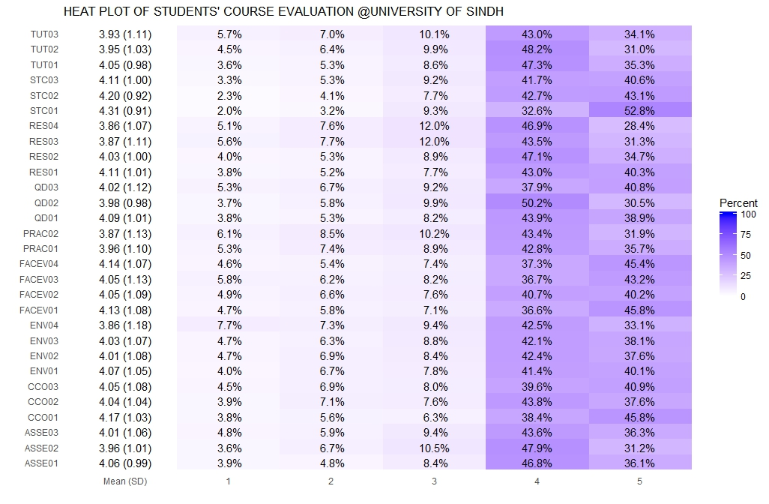

*Note: The indicators’ prefixes are used combined with question no. as row names.*

The pie chart shows % overall satisfaction of students in these departments:

However, various departments differ in their students’ satisfaction and based on the mean values they received from each student, boxplots have been devised which are then sorted based on their medians as below:

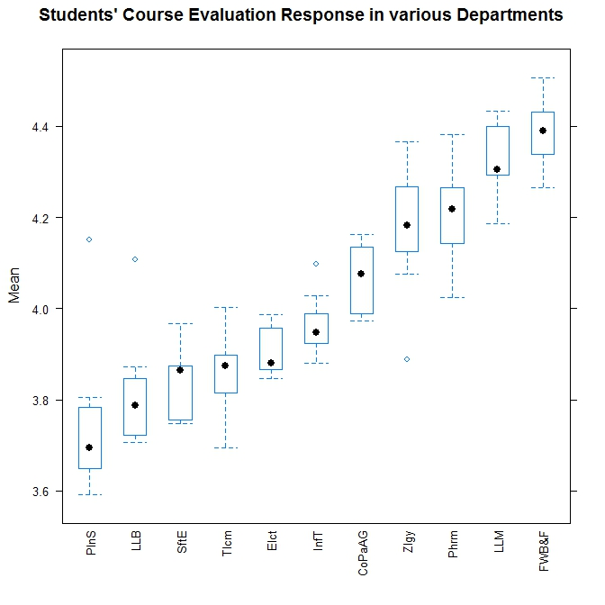

It is however, not clear why some departments show low mean responses from their students, therefore, questionnaire-indicator-wise plots have been devised to distinguish students’ responses as below:

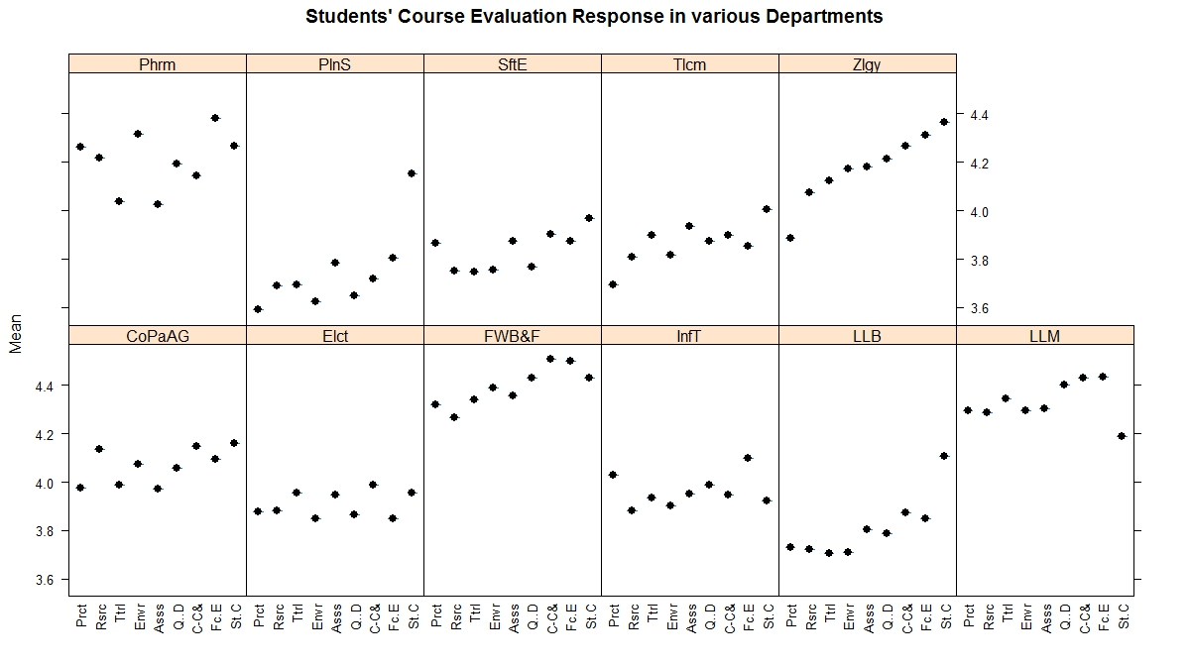

Its observed in above plot that in Plant Sciences, which shows lowest mean values, the reason may be practical and Environment which show lowest mean responses in Plant Sciences. Like wisely Telecommunication Technology and Zoology also show relatively low mean response of indicator of practicals.

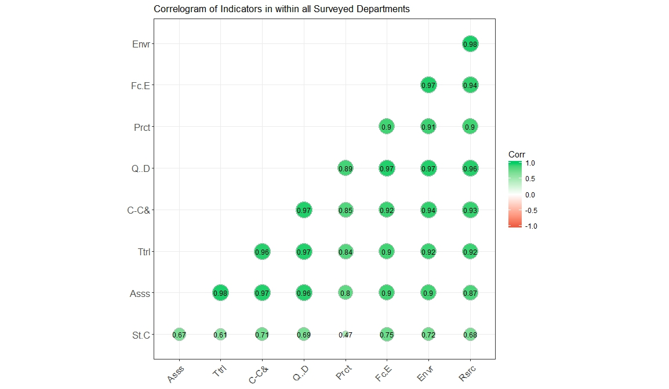From above plots it is explored that practicals show lowest mean values however it is still not clear to what extent it is lower than other indicators, therefore correlation of all indicators have been devised and the results have been prepared to show in the correlogram below:

The Practical show the lowest correlation of 0.47 among all others. This correlation is very weak. Hence, the need is to emphasize on correcting this weakness specifically in some departments.

The questionnaire-wise stacked bar plot was also devised to distinguish between parts of the Indicator-Practical as below:

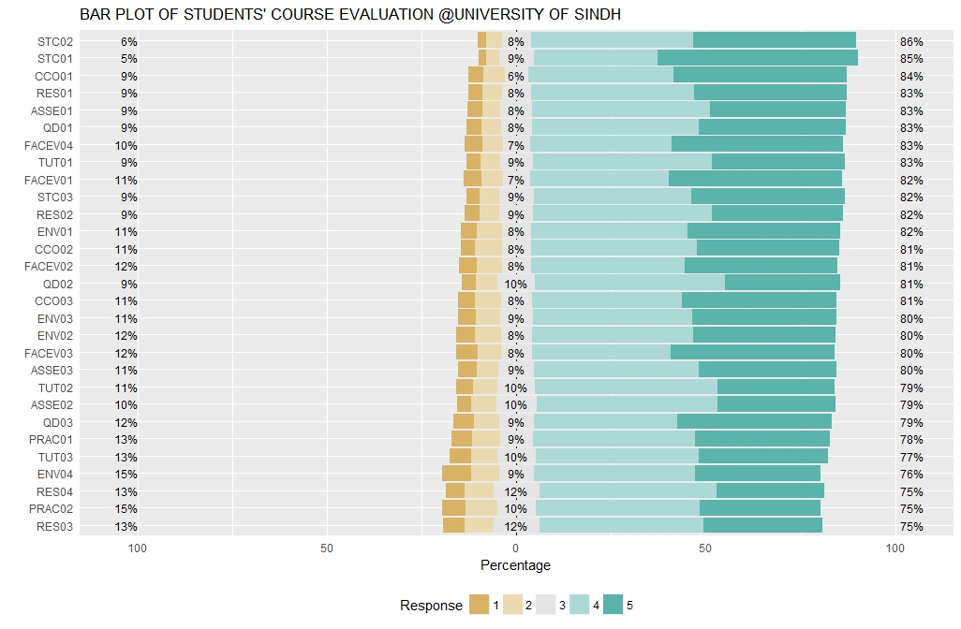

The lowest mean responses are in questionnaire denoted by PRAC02 and RES03 in the plot above, which correspond as under:

|  |  |
| --- | --- |
| PRAC02 | The Teacher dealt effectively with my problems during |
| RES03 | The provision of learning resources in the library was adequate and appropriate | |

The above plot may be further referred for exploring further responses.

Moreover, Students Course Evaluation Survey, in all programs and classes, was sent through Google Forms to emails of all University enrolled students. There were total 2184 responses for Students’ Course Evaluation Questionnaires from all the departments.

The overall response summary is plotted in the heat plot below:

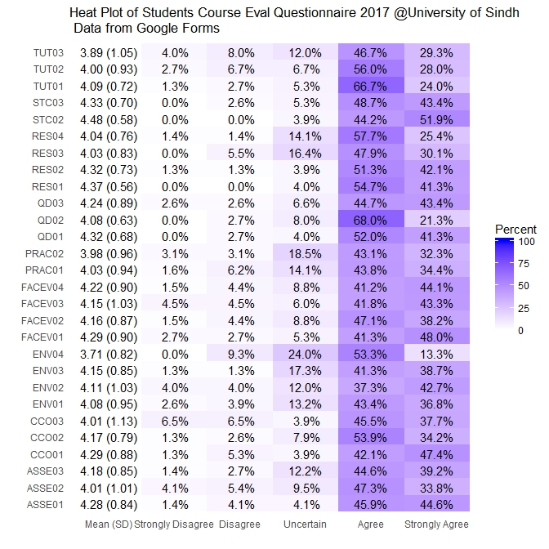

The lowest mean value is in 4th question (ENV04) under the Environment and Learning Resources. The question states: “Classrooms were satisfactory”